**Task 1 Development – Tom H**

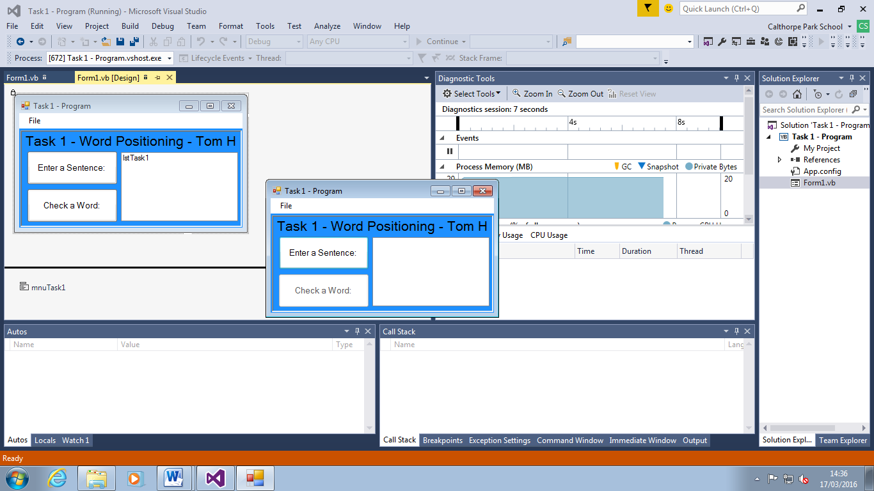

I have designed the outside form look of the program with the title, buttons and list box all organised neatly. I have coloured the form to a more user friendly colour making it look much more aesthetically pleasing.

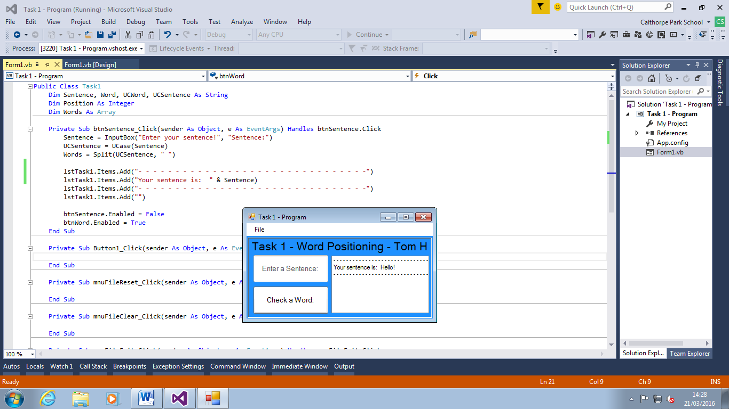

I have declared all of the variables and an array that splits the entered sentence into the array by every space. There is an input box that gives the user a place to choose what sentence they want with direct instructions. The buttons become enabled and disabled interchangeably too.

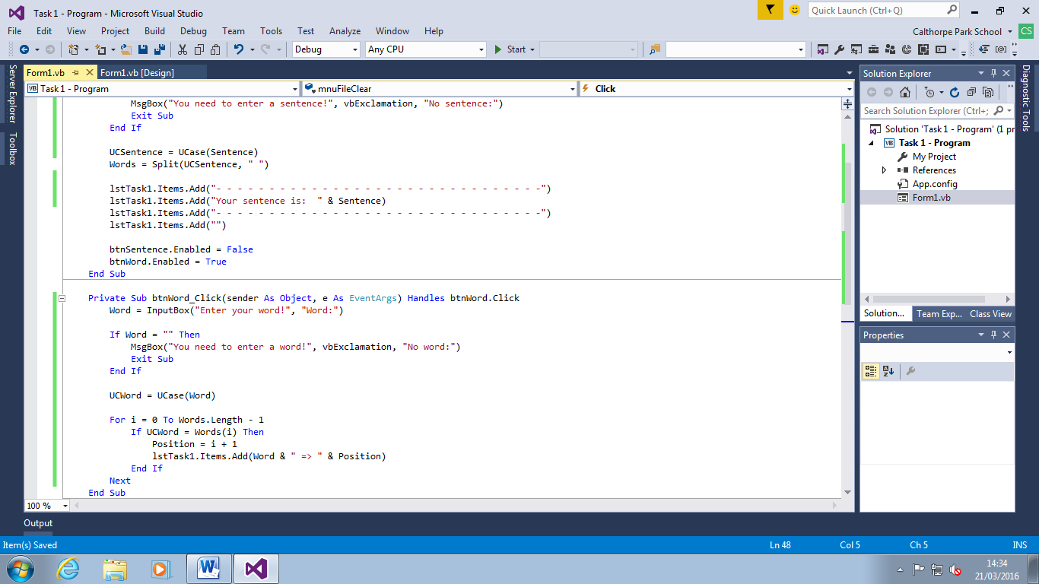

The program now finds the location of the word in the sentence if a sentence has been entered. I have added validation in case no sentence or word has been added.

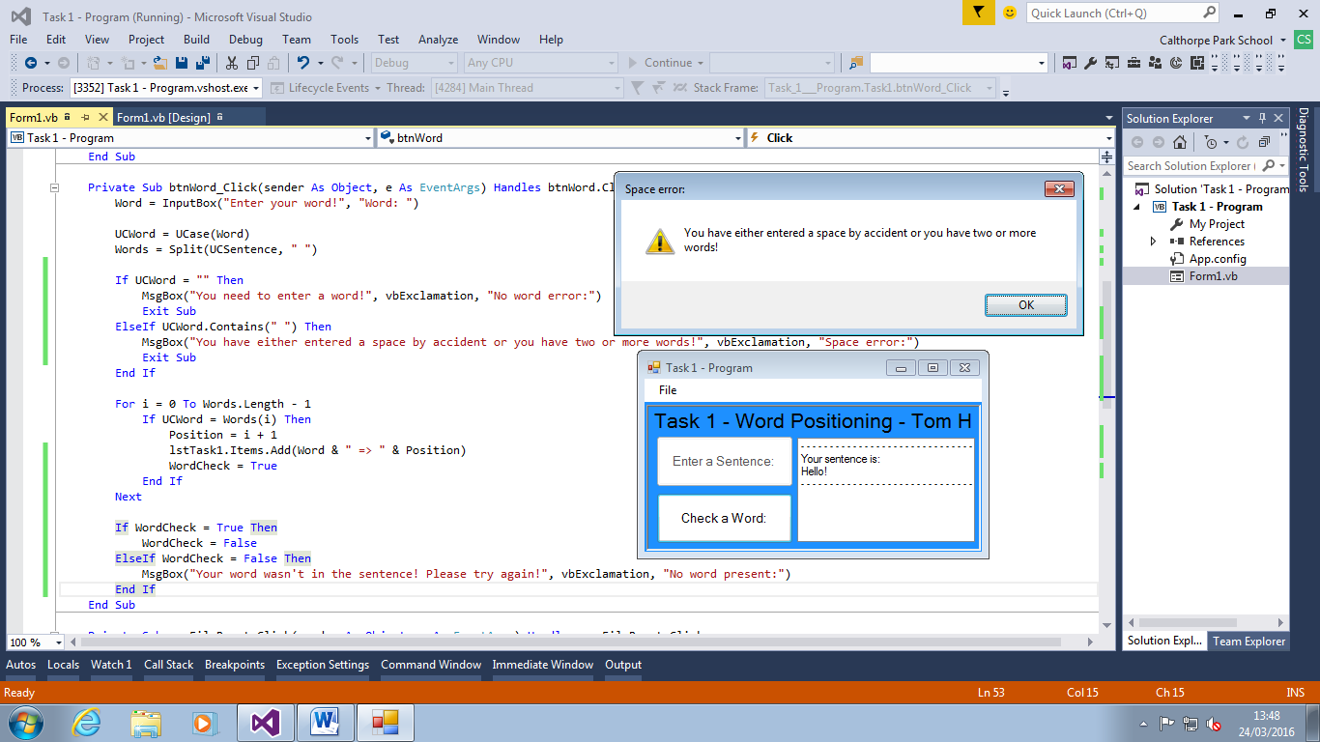

I have added more validation to my button that finds the words in the sentence by checking whether or not anything has been entered, if two words have been entered and if the word wasn’t in the sentence. I also changed the list box horizontal scroll property to true so long sentences don’t carry on beyond the list box horizon.

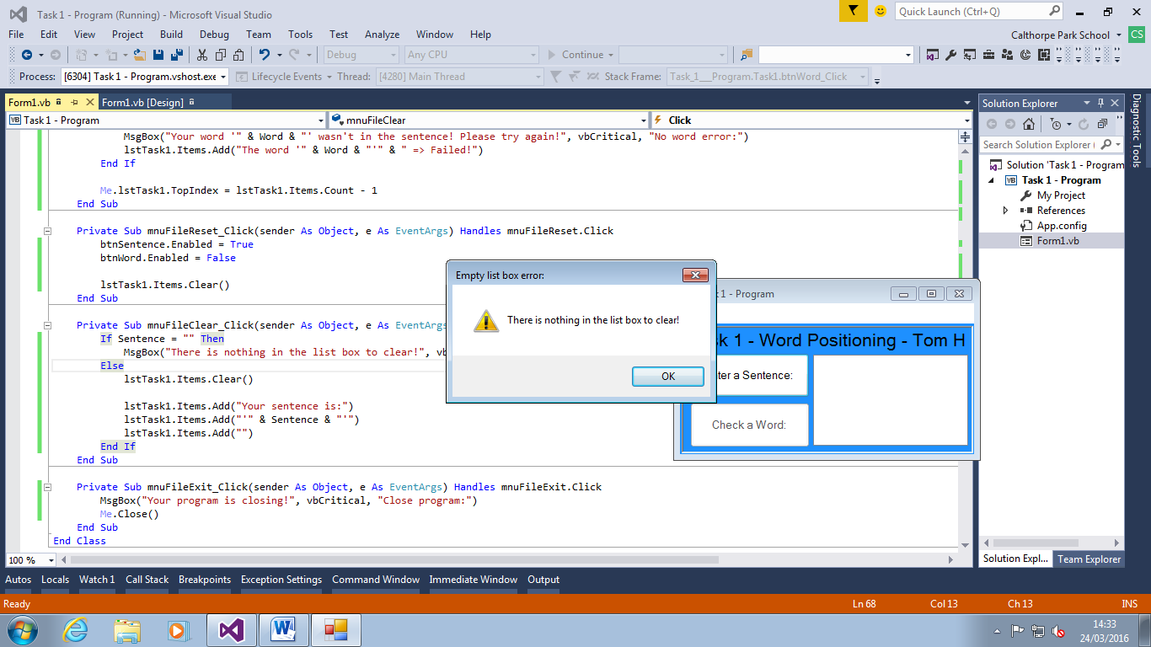

I have done my code for the menu strip buttons with full validation. In my word button I added a line of code that automatically scrolls down the list box when it fills up at the bottom. I changed the messages of some of my message boxes to a more ‘user friendly’ message. They’re easier to understand and read whilst providing the information concisely.

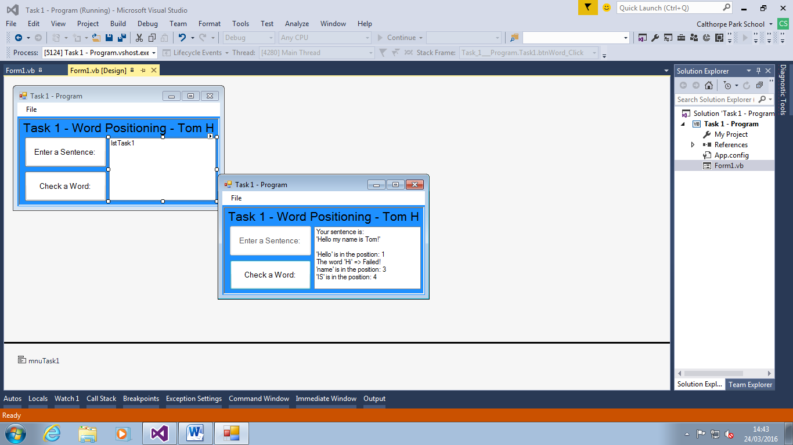

I have finished my code and everything is validated and works regardless of case. I have commented all my code and I have made sure that all the requirements in my success criteria have been met in my code.